The title should be concise and informative

Fist Author ¹⁾, Name who presents the work ²⁾, Third Author ³⁾
- The name of the first institution, address, post code, country
- The name of the second institution, address, post code, country
- The name of the third institution, address, post code, country

Corresponding author’s e-mail: abc@defg.ihjk.com

The abstract of a research paper should include a brief background of the research, the main methods used in the research, the major results and interpretation, conclusion and possible perspectives.
All text should be written in correct English, 12pt and in Times New Roman. The subscript such as NaNO₃ and superscript such as ⁵⁵Fe should be correctly used. A few tables can be included in the abstract.
Table 1 Analytical results of the major radionuclides measured using LSC
Rank1 | Rank2 | Rank 3 | Rank4 | Rank 5
Raw1 | 12.45±0.32 | 12.45±0.32 | 12.45±0.32 | 12.45±0.32
Raw2 | 12.45±0.32 | 12.45±0.32 | 12.45±0.32 | 12.45±0.32
Raw3 | 12.45±0.32 | 12.45±0.32 | 12.45±0.32 | 12.45±0.32
Raw4 | 12.45±0.32 | 12.45±0.32 | 12.45±0.32 | 12.45±0.32

A few figures can be also included in the abstract.
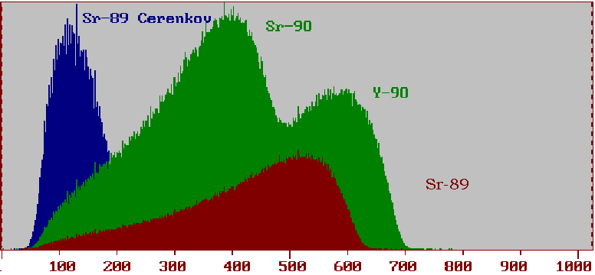

Fig. 1 The LSC spectra of ⁸⁹Sr and ⁹⁰Sr
References:
- Rhodes B.A., Liquid scintillation counting of radioiodine, Anal. Chem., 37(1965) 995-997.
- Lehto J., Hou X.L., Chemistry and analysis of radionuclides: Laboratory techniques and methodology, Wiley-VCH, 2011.

